“Quality, Fairness, Value”

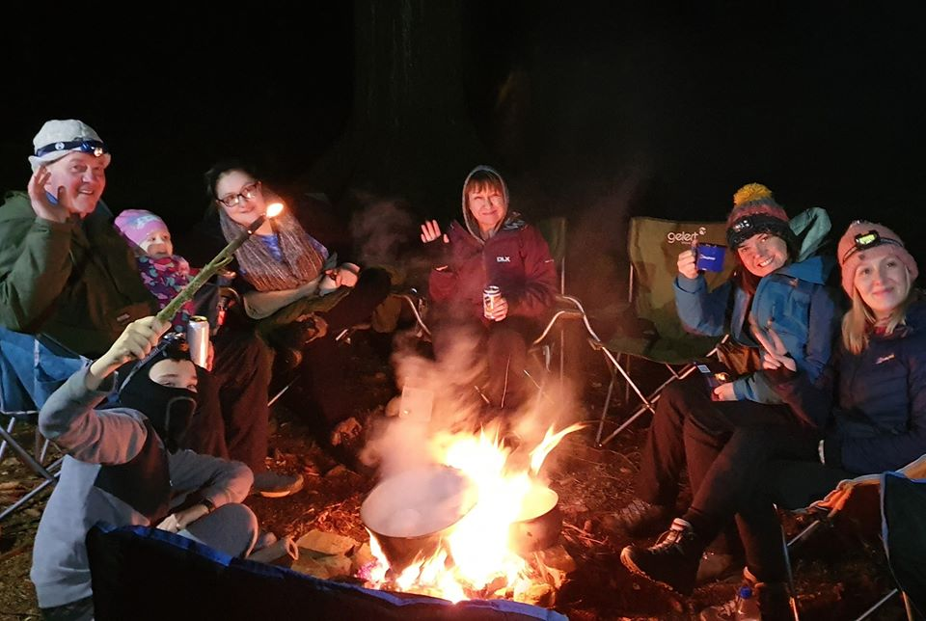

West Highland Way

The West Highland Way Experience

Description:
The West Highland Way is one of Scotland’s iconic walking routes, the first long distance walking route in Scotland it is also the most popular and it is not hard to see why. A little over 150km in distance it takes in lowlands, highlands, lochs and forests and offers up a unique view of Scotland and her beauty.
Along the route you will see the dark and mysterious Loch Lomond, walk in the shadow of both Ben Lomond and Scotland’s highest mountain, Ben Nevis, you may encounter our famous Red Deer and they may even let you feed them, look out for birds of prey, soaring eagles and notably the Red Kite which is making a comeback in our somewhat dramatic skies
There are places to visit, stop for a drink, be careful around the Drovers Inn though, it is reputedly Scotland’s most haunted Inn, a fair few stories have emerged from within, but that is to be expected as it is 315 years old.
One story that is not a myth is the welcome you will get both in the Drovers and throughout the route. Scot’s are famous for our friendly banter, our sense of humour and our passion, some may mistake us as being grumpy and mean but don’t believe it, that is a story fuelled by jealous neighbours.

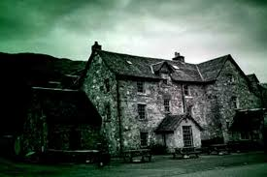

About T.M.M. Experiences

T.M.M. Experiences is the new name for the wild camping division of The Mountain Men Ltd. Organised and run by Ritchie Nash, a family man and ex Scottish Infantry soldier. Ritchie prides himself in making sure T.M.M. Experiences is the best they can be and on giving you the best experience possible. Three watchwords, "Quality, Fairness and Value."
For your West Highland Way Experience we can train you, supply you and support you throughout the whole experience, we take the stress out of the journey allowing you to relax into it and enjoy your time on the trail.

The Mountain Men Ltd/T.M.M. Experiences
Registered in Scotland: SC611785
2nd Floor, Clyde Offices
48 West George Street
Glasgow, G2 1BP

0141 4827005

info@tmmexperiences.scot
www.tmmexperiences.scot

So how will it all work?

The best way to explain it is to tell you a story, not a famous story or a colourful story nor one ever published in a magazine but a story that can unfold and be filled with your fame, your colour and published in the best magazine of all, your memory.
Once upon a time, “well come on all good stories start that way…..true”?

One day Jockie MacQuackle decided he wanted to walk the West Highland Way, he sat down and had a think, well where do I start? When do I start, how do I get to the start? Oh my! What about accommodation, food, shops, kit I need and how to carry it, so many questions, google, yes google, that is the answer…….so much conflicting information where do I start?
Jockie sat back and scratched his head, he closed his eyes and promptly fell asleep in his chair, Jockie was notorious in his own head and he was prone to dreaming, he loved his dreams as they often told him what he wanted to know, as it happens sitting there in his chair he started to dream, in his dream he came face to face with a handsome buck stag called Tam, this fine specimen of red deer came to Jockie with one message, simply put it was to relax, it would all be fine, just wake up and phone T.M.M. Experiences.

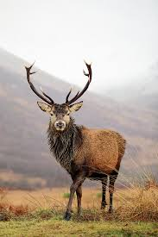
So Jockie did just that and good old Ritchie explained that they would take care of everything for him.
Jockie heard how he could be picked up (within reason) and taken to the start point of the walk, how T.M.M. could teach him how to walk using a map and a compass and supply him the maps and route card he needed to complete the walk.
They went on to tell him that they would give him a hearty breakfast of good old Scottish fayre to set him off on and that they would be waiting for him at the end of each day with a prepared camp site set up, dinner on the go, a bed to flop onto and some hot salty water to soak his tired feet in.
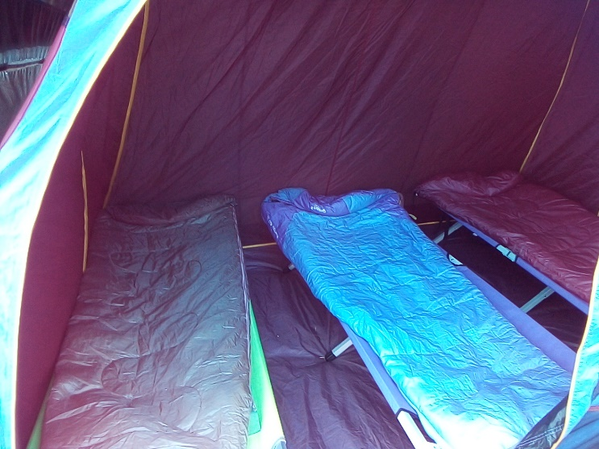
What about kit and accommodation Jockie enquired and got a very satisfactory answer as The Mountain Men informed him they could happily supply all the kit he needed both for the walk and for the camp, with this revelation he got a bit cheeky and asked how he would carry it all and to his delight and surprise he was told not to worry that T.M.M. would carry everything from place to place and that he could walk with a light pack only, some snacks and drinks and maybe some waterproofs, travel light was the message.

“What about toilets at night and what if I need a shower or have wet clothes, can you fix all of that also?” he asked sceptically, “Yes” Ritchie said, we supply a covered toilet in camp and on at least 2 nights we will book into a camp site to allow you to shower and use the facilities, we will even help with the laundry but not your smalls, we draw the line at smalls.
Jockie was almost sold but he was scared to ask how much all this was going to cost him, after all these people were going to train him, supply him with the maps and the routes, they were going to be his taxi to the start point and back again, they were sorting all the accommodation and dinner and breakfast and they would even help with his washing if required (not his pants though, he would put them away in a dry bag for when he got home, nobody wants to see his pants). They even seemed like nice people which was a bonus and seemed to know their oranges.

“How much for this wonderful award winning, 5-star service then” he asked?
“Well here’s the rub…..” started Ritchie, Jockie felt a pang of dread, “that depends…” Ritchie continued and Jockie was perched on the edge of his chair.
“If you book one or two places the charge is…..” Wait for it….
£220 per person
Bring more friends or family and for 3 or more we will discount it down to £200 per person, all inclusive, buy your own booze though”
Jockie missed the last bit though as he was still picking himself off the floor!

Based on 6 days, 5 nights, all-inclusive including camp, equipment, dinner, bed and breakfast, packed lunch, training, route cards, maps, compass, baggage carry service, carriage to start and return from end of WHW and the odd wee treat shop

